VIETNAM INTERNATIONAL UNIVERSITY – HO CHI MINH CITY
INTERNATIONAL UNIVERSITY

WEB APPLICATION DEVELOPMENT
PROJECT

By
Huynh Pham Trung Nguyen – ID:ITITIU21261
Nguyen Duc Duy – ID: ITITIU21008

Advisor: Dr. Nguyen Van Sinh
Advisor: Nguyen Trung Nghia
A report submitted to the School of Computer Science
and Engineering in partial fulfillment of the requirements
for the Final Project
in Web Application Development course – Sem 1-2026

I. INTRODUCTION
In the contemporary retail environment, the shift toward digital-first consumerism has transformed high-performance e-commerce platforms from a luxury into a strategic necessity. Modern consumers demand speed, reliability, and intuitive navigation, particularly in the high-stakes hardware sector. To meet these expectations, businesses must deploy robust, scalable web architectures capable of handling complex data transactions while maintaining a seamless user experience. This report details the development of " E-commerce-Fashion-website," a platform designed to bridge the gap between premium hardware retail and high-end digital interaction.

1. ABOUT US
E-commerce-Fashion-website is a premium provider of high-performance laptops and technical accessories. The vision for the platform was to create a global, scalable digital storefront that prioritizes a frictionless User Interface (UI) and a sophisticated User Experience (UX). By focusing on efficient data handling and a "digital-first" approach, E-commerce-Fashion-website aims to provide a professional environment where technology enthusiasts and professionals can browse and acquire the latest hardware configurations with ease.

2. THE PRODUCT’S INFORMATION
The E-commerce-Fashion-website platform serves as a comprehensive retail ecosystem tailored for the laptop niche. Core features integrated into the platform include:
- Latest Collections & Best Sellers: Dynamic sections displaying recently added hardware inventory and high-demand units (e.g., top 5 trending workstation models) to guide consumer interest.
- Hardware Category Filtering: Users can refine searches based on technical utility (Gaming, Workstation, Ultrabooks) and specific hardware specifications such as processor tiers (Intel i9/Ryzen 9) or storage capacities.
- Contextual Search Functionality: A real-time search bar that allows users to query the database by technical keyword (e.g., "RTX 4090" or "OLED display"), immediately narrowing the product list to relevant Stock Keeping Units (SKUs).
The "So What?": These search and filter features are critical in reducing consumer friction. By allowing users to locate specific hardware configurations in seconds rather than browsing through irrelevant listings, the platform significantly increases conversion rates and enhances user retention.

3. WORK BREAKDOWN STRUCTURE
The project was executed using an Agile methodology, facilitating iterative development and continuous validation of core modules.
Phase | Title | Description
Phase 1 | Specification | Defining business requirements and designing schemas for multi-variant products (e.g., multiple high-res images and spec-tiers per laptop model).
Phase 2 | Build Database | Designing the MySQL relational schema to ensure strict data integrity for users, hardware inventories, and transaction logs.
Phase 3 | Interface | Developing a responsive UI using Tailwind CSS principles, adhering to the " E-commerce-Fashion-website" premium tech aesthetic.
Phase 4 | Testing & Validation | Iterative bug fixing and integration testing, focusing on real-time synchronization between the Admin Panel and Client storefront for order status updates.
This approach ensured that core modules—User Authentication, Product Management, and the Cart/Purchase flow—were validated against specific user requirements prior to deployment.

4. DEVELOPMENT ENVIRONMENT
The technology stack was strategically selected to provide a balance between asynchronous performance and structural rigidity.
- Express/Node.js: Utilized for backend logic to handle asynchronous requests and server-side processing of API responses.
- MySQL: Chosen for its structured, relational data integrity, allowing for complex JOIN operations between product variants and order history tables.
- MVC Architecture: Employed to maintain a clean separation between business logic (Controllers), data structures (Models/Schemas), and the presentation layer (Views).
- Docker: Used to containerize the application, ensuring environment parity across development and production while maintaining deployment stability.
This environment establishes the technical foundation required for the deep requirement analysis and system design detailed in the following section.

II. REQUIREMENT ANALYSIS AND DESIGN
Rigorous system design is fundamental to preventing technical debt. By mapping out the data flow and architectural components early, we ensure the application remains scalable and maintainable as the hardware inventory grows in complexity.

1. REQUIREMENT ANALYSIS

A. FUNCTIONAL REQUIREMENTS
The system is bifurcated into two primary user roles, each with specific capabilities:
- User Roles:
  - Account creation and secure login.
  - Product Gallery interaction, including the ability to switch main images via small thumbnails.
  - Dynamic cart management with specification-selection logic (e.g., selecting RAM/Storage upgrades).
  - Multi-payment gateway selection, supporting Stripe, RazorPay, and Cash on Delivery (COD).
  - Real-time order tracking (e.g., viewing status updates like "Ready to Ship" or "Out for Delivery").
- Admin Roles:
  - Inventory management, including multi-image uploads and setting specific technical attributes.
  - Real-time order status updates that synchronize immediately with the user’s "My Orders" dashboard.
  - Categorization of products as "Best Sellers" to influence front-end rendering.

B. NON-FUNCTIONAL REQUIREMENTS
- Usability: The platform is fully mobile-responsive, ensuring a consistent experience across all device sizes.
- User-friendliness: A minimalist design philosophy with clear calls to action (CTAs), such as "Add to Cart" and "Proceed to Checkout."
- Maintainability: Following MVC principles allows for independent updates to the UI or the database without system-wide downtime.
- Interface: Consistent branding through the E-commerce-Fashion-website premium tech aesthetic and rapid page load speeds achieved via optimized asset delivery.

2. DESIGN

A. ERD DIAGRAM

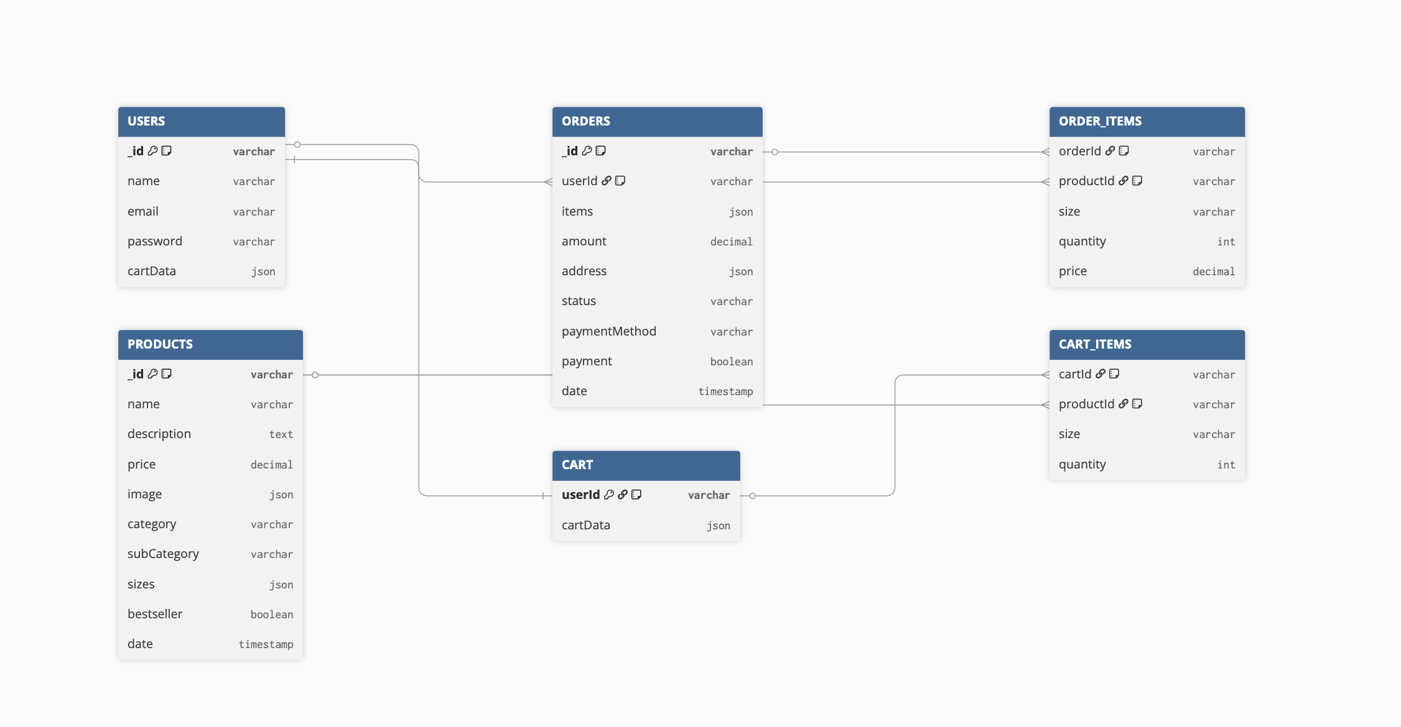

B. RELATIONAL SCHEMA DIAGRAM
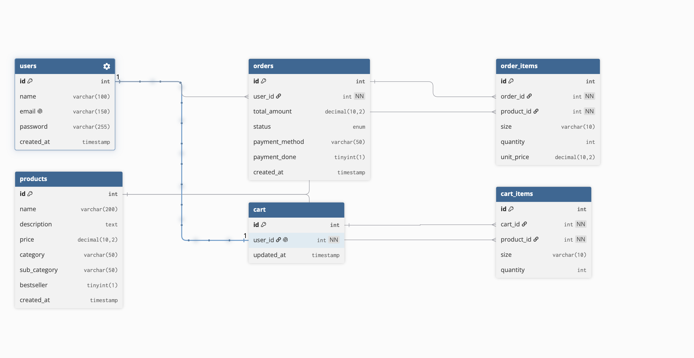

C. CLASS-DIAGRAM
- a. FRONT-END: The component hierarchy is structured for reusability, featuring core elements like Navbar, Hero, ProductItem (handling hardware SKUs), CartTotal, and a specialized ProductGallery for thumbnail switching.
- b. BACK-END: The server-side is organized into specialized controllers (e.g., userController, productController) and route handlers (e.g., adminRouter, productRouter).
- c. LOGIC FLOW OF BACKEND API: Data follows a rigorous lifecycle: Client API Request -> DTO (Data Encapsulation) -> DAO/Service Layer (Relational Abstraction) -> SQL Query Execution (via Sequelize/TypeORM), and the reverse response flow.

D. USER CASE DIAGRAM

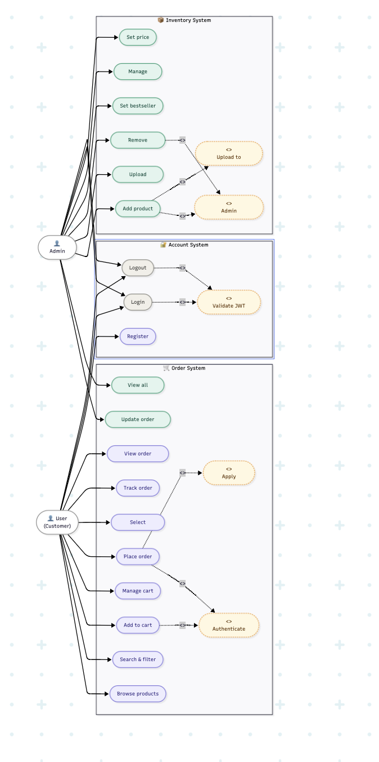

E. API
Path | Method | Use Case
/api/user/register | POST | Facilitates new user registration and token generation.
/api/product/list | GET | Retrieves all Hardware SKUs from MySQL to render the Collection page.
/api/product/add | POST | (Admin Only) Handles multi-image uploads via Multer to Cloudinary for new hardware.
/api/order/status | POST | Updates delivery state (e.g., "Out for Delivery") for specific Order IDs in the database.
/api/cart/get | POST | Retrieves persistent cart data for logged-in users from the relational schema.
These design blueprints directly informed the implementation phase, ensuring the code adhered to the planned logic.

III. IMPLEMENTATION
The implementation phase translated design specifications into a live, interactive environment. A major focus was placed on the E-commerce-Fashion-website premium tech aesthetic, which was achieved using Tailwind CSS. This utility-first framework allowed for rapid UI development while maintaining a lightweight, performant codebase.
Key technical implementations included:
- The Search Bar: Leveraged the useLocation hook to ensure the search interface is context-aware, appearing only on relevant pages (like Collections) and remaining hidden on others.
- The Navigation Bar: Implemented NavLink for active state management, providing users with visual cues based on their current route.
- Newsletter Box: Integrated a subscription component utilizing preventDefault() on form submission to handle data asynchronously without page reloads.
- The Policy Section: Utilized Tailwind’s responsive grid (Flex Row to Flex Column) to ensure that service guarantees (Exchange, Return, Support) maintain a premium feel on mobile devices.
- State Management: Centralized the application logic using ShopContext. This context provider handles global variables, such as cartItems and the getCartAmount function, ensuring that quantity and spec updates are immediately reflected in the navigation bar's cart icon.
This implementation was subjected to rigorous evaluation to identify and eliminate potential engineering bottlenecks.

IV. DISCUSSION AND CONCLUSION
The development of the E-commerce-Fashion-website platform successfully met the overarching goal of creating a production-grade retail application for the laptop market. By combining modern frameworks with structured architectural principles, the project demonstrated the feasibility of a high-performance retail system optimized for complex hardware variants.

Technical Reflection & Challenges
Several engineering challenges were addressed during development:
- State Synchronization: Managing real-time cart counts across multiple disparate components (e.g., Header, Cart Page, Product Page) required a centralized Context API to prevent data mismatch.
- Data Integrity: Maintaining relational consistency in MySQL during the checkout flow—particularly during multi-step payment processing—required careful transaction management to ensure orders and inventory remained synced.
- Docker Isolation: Transitioning from local development to a containerized environment revealed minor pathing issues with asset storage and environment variables, which were resolved through Docker volume mapping and configuration auditing.
Optimizations: The application utilized asynchronous Node.js processing to handle high-concurrency requests, and MySQL indexing was applied to product categories and hardware specs to maintain rapid search speeds as the database grows.
Conclusion: The project successfully met the School of Computer Science and Engineering’s academic standards. Future iterations will focus on cloud migration and advanced security auditing for the payment gateways to further enhance platform stability.

V. REFERENCES
- Node.js Documentation: Official guide for asynchronous server-side JavaScript execution.
- MySQL Documentation: Relational database management and schema design best practices.
- Docker Official Documentation: Containerization strategies and environment parity.
- React JS Documentation: Implementation of Hooks (useLocation, useContext) and component lifecycles.
- GreatStack Technical Frameworks: Methodologies for e-commerce logic, Multer integration, and payment gateway implementation.

